**Intermediate Term Top Down Analysis - Weekly To Daily**



The first thing in the beginning of a new week is looking at relative strength, the reason being: we may not have a clear picture of the monthly analysis. So to avoid the frustration if the monthly is not clear then relative strength will help.

And if we take the example of aussie for the monthly, then we hope it would fit the criteria of the weekly relative strength analysis as well



Go trough all the currencies and commidities, we'll get trough the specifics later We want to see what the commercials are doing

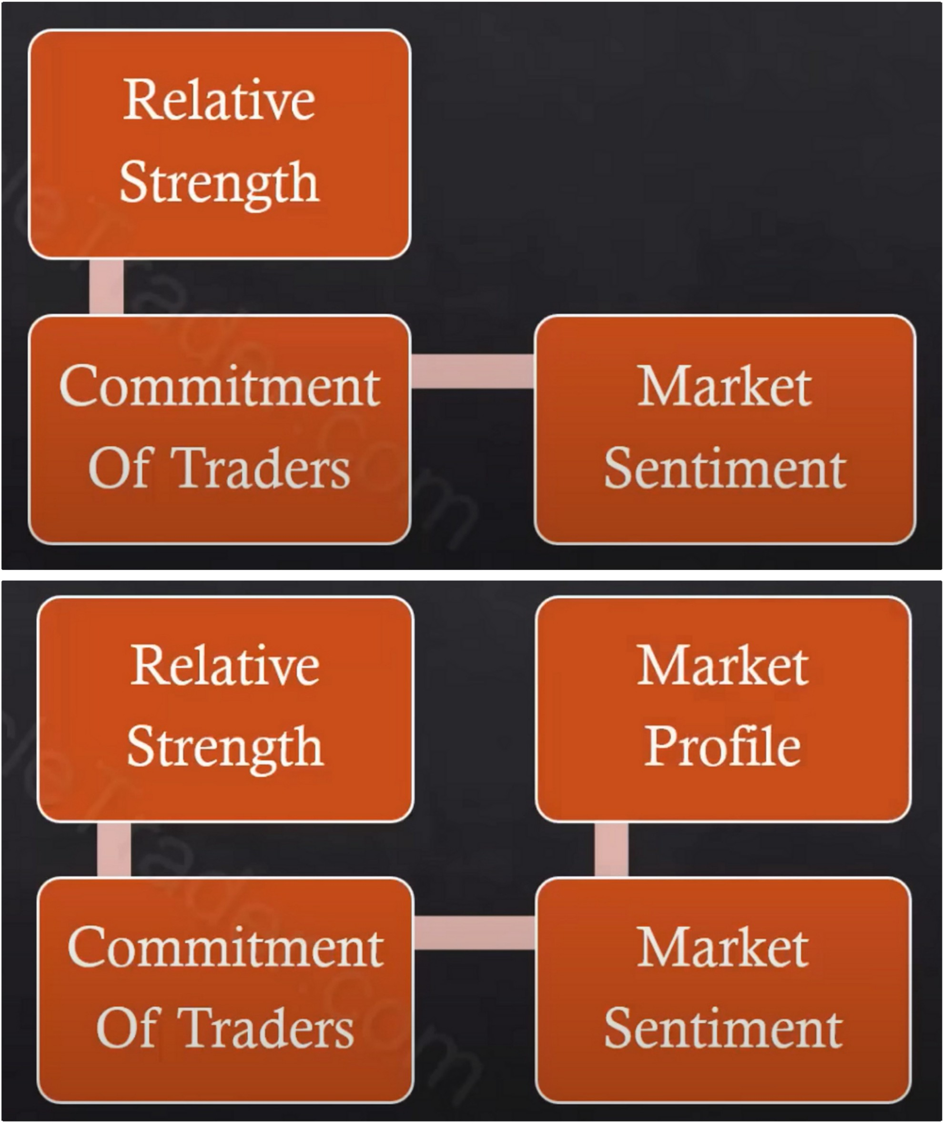

Notice how we have different things on the weekly then the monthly analysis, once we get to the weekly we start to look more at the opinions of others versus just technicals and we weigh them against the technicals strengths and weakness by way of the relative strength analysis, once we arrive at our watchlist and the COT hedging ideas, then we move to the market sentiment and get an idea of what eveyrone in the retail world is thinking ideally you want to do the opposite of what retail is thinking and doing. Then we look at what the weekly looks like in terms of market profiles, consolidation, trending or retracement

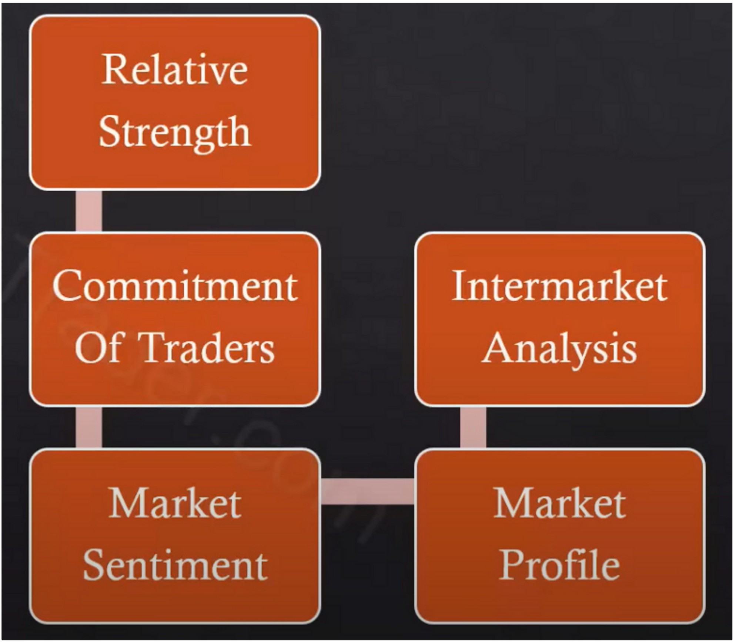

Start comparing what the weekly chart looks like in other correlated markets Dollar vs kiwi for example

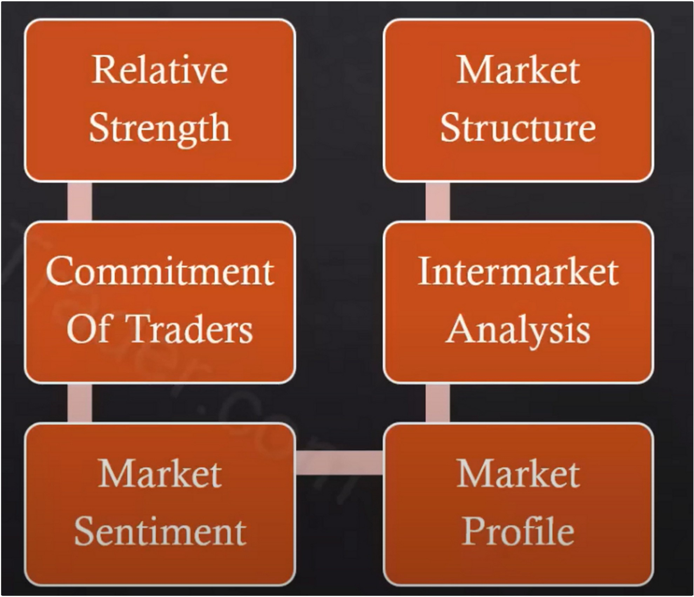

Then market structure, and at this point we want to start blending in the idea of institutional orderflow, downclose candles supporting price if bullish and upclose candles being broken, vice versa for downmoves.

Everything from the monthly on market structure applies, so the SMT still applies but now were going to start heavily looking for the institutional orderflow and institutional sponsorship by studying the orderflow

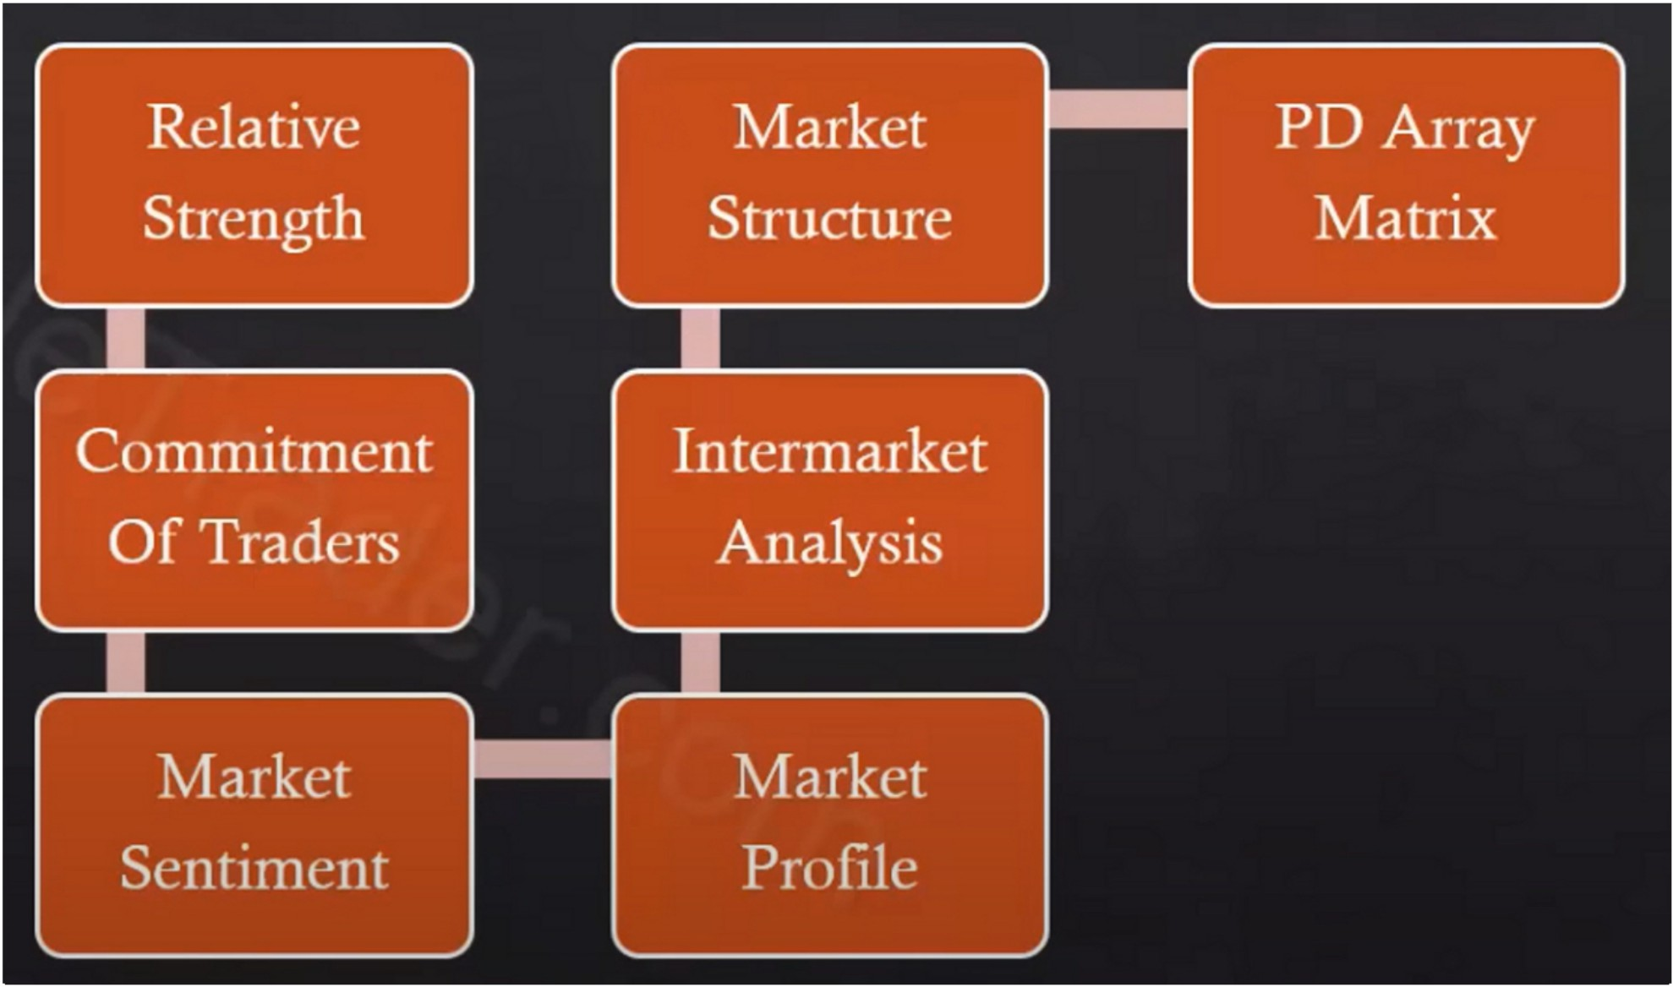

PD array matrix, we do the same thing as we did on the monthly chart

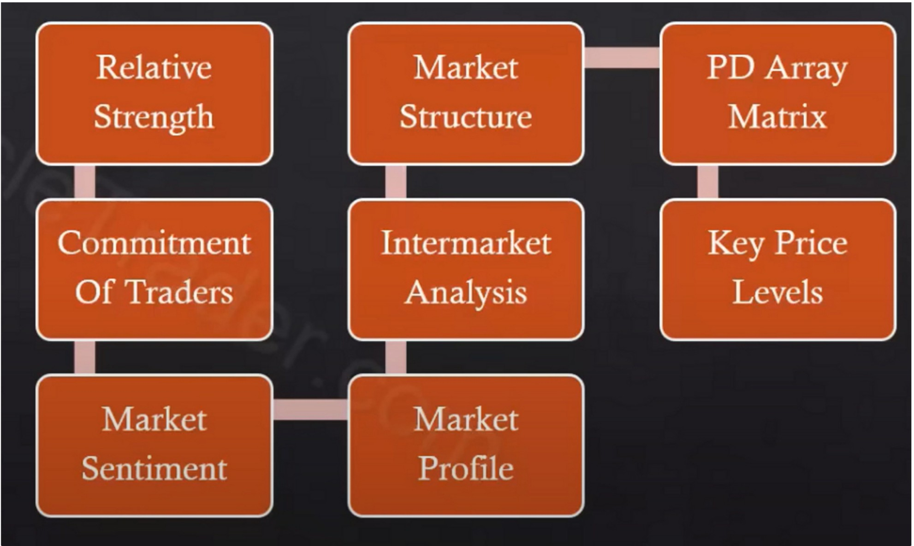So everything that i would break down in terms of the range that is now defined on the weekly chart, any PD arrays that did not exist on the monthly chart may now be visible on the weekly chart

By having the PD array matrix defined we can start working towards calibrating our key price levels

Relative Strength

PD Array Matrix

Market

Structure

Strength

PD Array Matrix

Market

Structure

Commitment Of Traders

lntermarket Analysis

Key Price Levels

Commitment Of Traders

lntermarket Analysis

Key Price Levels

Market Sentiment

Weekly Bias Defined

Market Profile

Market Sentiment

Weekly Bias Defined

Market Profile

And then we have the weekly bias and we can transpose it to the daily chart



Relative strength analysis

We want to look for the strongest to trade them and the weakest to avoid them or potentially form a forex pair with

\\ I I I I ,ii 11 I • Ii I

I illnk *Im* the L'll111111crc·i,lis tn lie ,lt .1 I::>nwnth llr 6 mllnth nt renll' in Net I lold1ngs I ,lisll Sllrt m.irkcts th.it

,ll'L' ,ll :' .ind --l VL'.ir L'XtrL'tnL's

l_; s111g Ill pnlptil'(.trv C(rrl ll'dg111g Pn 1gr,1111 L'<Hll"l'PI lnnk l(lr signs thl' Cn1111nt'rl·1,lls .ire hu,·111g nr sl'llin ,1 111-irk,·t •

I l1kl· !ti '-tirt l.t)lll!ll1\ll1t1L'" th,11 h,1\c t'\l!L'tlll'h l,in:t· ".t'l

0

Iltilll:n:...:, llllll)',lll\l (tl!Ill' l·u:·.irt· l 1ltl",l\' llll'\ ,lll' lll

**Commitment**

**Of Traders**

Relative

Commitment of traders

Commercials create the highs and lows of the market place and if you know where the highs and the lows are that they create and what theyre likely doing then you have a large range to play in for the expansion, catch the meat in the middle.

We want to use the commercials to give us the high and the low end of the range based on their extremes, we trade with the direction of the large funds in the middle. So at the highs and the lows of the tops and the bottoms you'll see the commercials are always right, in between those two price points tha large funds are accurate and they're right. Thats why hedge funds continuosly make a lot of money, but at the extremes they always get their ass handed to them. So we want to know when

the hedgers are calling for a potential high or low and we work within the middle.

We like to see commercials buying when it isnt obvious, like below the O line and look at that range of the 12 month extremes and divding that in half.

If theres a huge amount of net long positions in the soybean market versus all the other green market then generally thats going to be indicative of seeing a big move as well



Market sentiment reading

We look for stories that have real big headline like: "Doom and gloom" "Best bull market ever seen" Headlines that get people emotionally charged

The more emotionally descripted they are and the more they occur then generally that builds in a sentiment idea

If the technicals are in line like ICT teaches it and retail is saying the opposite of what were seeing then its super high probability

For the williams %r look for which period is the most accurately depicting with highs and lows

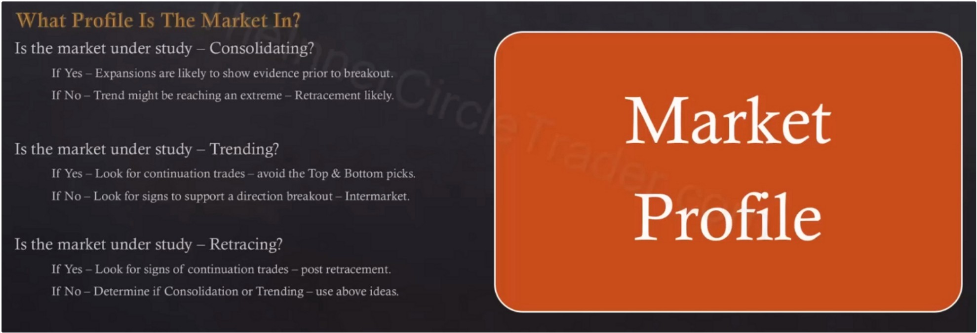

Same as on the monthly

First choice is always retracement and not reversal, since we dont pick tops and bottoms

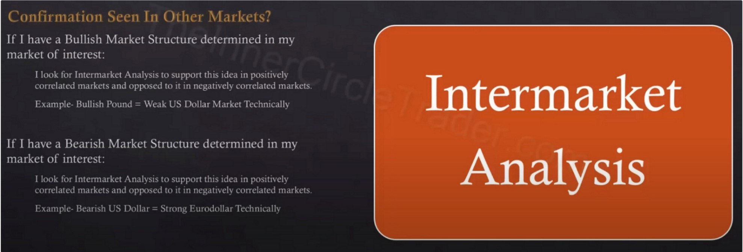

Same as on the monthly

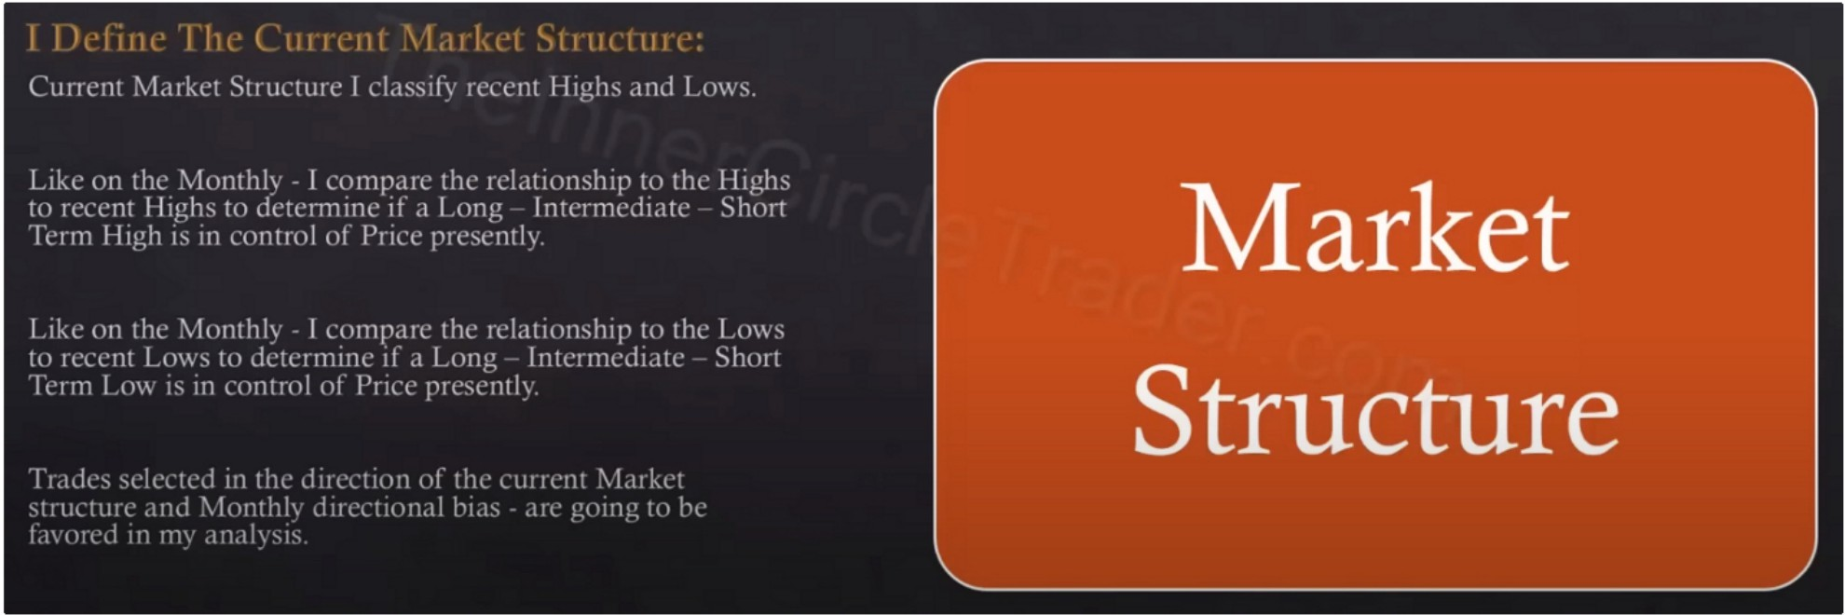

Start incoorporating institutional orderflow here, premium arrays breaking in bullish markets discount arrays supporting pice

SMT ideas

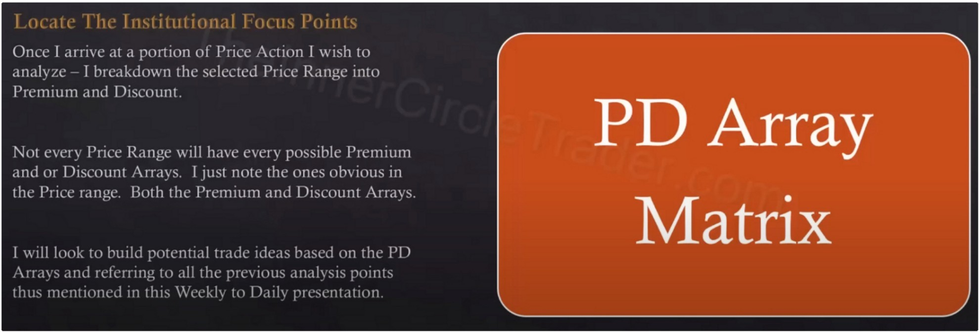

Break down the selected price range into premium and discount

I I I

Once I ,ktcrnrn1c the pm11011 ol 1\l,11kct Stru,·turc I \\·,1111

tn use for 111v tr hil' 1dL· 1s:

l.1kc· 011 th,· 1\1,,nthl\ I rnund ,-.1d1 l'I) Arr,I\ Ill the 11c.11c,1 10 Incl <ll 5 lc,d

Thl' l'll'l1lllll1l :\11,1\S ,lbil\l' c-l.11kc·t 1'11,·,, ,Ill' ltlllllckd d11\\ll 1111/1t· lll.',IIL''t ,1d1t1,;tt·d Jllilllhcr It',i\rl..,r.111n11]

1·1il, 1 )i'-,(lllll: \11,t\'- h·lti\\ \l.1:kl·l 11:kl' ,l!t' 111L111--k,l ·,q'

t11 ·l:1,_· 11L·,1:L•'-i ,1,h:---tl·,'. :1:11::h·r ll·.1:1:''.1l:11:1

**Key Price Levels**

Example:

This was the monthly analysis

Once we break that range where we traded away from the bullish orderblock then its no longer valid

All the monthly PD arrays transposed to the weekly, that range is no longer valid but we do use the old high as discount array

Relative strength standpoint: no SMT or anything, just normal follow trough, weakness in the dollar and strength in aussie

We have a more refined PD array now

And we have a bullish orderblock on the weekly

Downcandles are seeing support, upclosed candles are being traded trough

Commitment of traders report, minute 28:30. Great explanation and way clearer

You can see in June they where above the hedging program of our modified O line of the 12 month range meaning theyre buying there and its near a 12 month extreme and it happens right when they close in that weekly FVG

Noticed this myself, but notice how the open interest declines heavily

ICT thinks they skewed the data to mess it up for retail traders. Its the law, CFTC require them to report this information

When its near the high or low end of the range its very indicative of a smart money accumulation or distribution

Perfect example of a headline we could use for sentiment

When these story lines starts building then we want to do the opposite

Uninformed crowds follow these headlines like sheep, like slaves

All the news events are there to build in sentiment, its conditional programming

20 is iffy

14 looks better

You dont always want to use the smallest one because the smallest one will generally always give you a good reading, sometimes thats a little too sugarcoated

This is the 10

14 is the best currently here, its a bit more stretched out

The lower the williams %r thats when retail thinks its bearish. the higher thats when the public is bullish

Sentiment was bearish, nobody was saying it was going to go up And we were bullish

Market profile

Were in a longer term consolidation but now its giving us clues at that time that price wants to break to the upside, if thats true then we should be looking for the profiling of a retracement. We had the impulse swing then the retracement and then the expansion swing, expansion swing tends to go a little bit further then the impulse swing does

So market profile is retracement to expansion

The PD array matrics, all the discount arrays support price

Now we transpose all the weekly stuff onto the daily chart

Notice how it is easy, its a process, we dont do everything on 1 timeframe